Viviana d'Auria
Department of architecture,urbanism and planning, KU Leuven

Manuel Mujica Millán
(born Vitoria, Spain, 26 May 1897, died Mérida, Venezuela, 13 February1963)

Considered the most significant neo-colonial/ neo-hispanic architect in Venezuela. In the course of his career the versatile Manuel Mujica Millán demonstrated a pronounced capacity to reconcile modern design and functionalist layouts with the revival and reinvention of vernacular forms and architectural dialects. As part of a larger neo-hispanic ‘awakening’, Mujica Millán found fertile terrain to manifest his eclecticism, stemming from the appreciation of pre-existing architectural production and the exigencies of directing future urban development in Venezuela. In the country as in other areas of the Latin American continent, the wider debate on national identity embraced that of modernization and the physical manifestation that overall progress would take not only in the case of new neighbourhoods and their configuration, but also in that of important state buildings, public spaces and company headquarters. The assimilation of nationhood with Venezuela’s hispanic roots, namely only one of its many sources, led to the emergence of a neo-colonial style that found much fortune in the late 1920s and 1930s in Caracas and was applied to novel typologies associated with the city’s modernization.

Mujica Millán reached Caracas in 1927 after growing up in the Basque city of Vitoria and completing his architecture studies in Barcelona. He arrived in Venezuela’s capital city two years after having completed his architectural degree, charged with the task of completing and expanding the Hotel Majestic. Above all the hotel represented a new type for the city, and Mujica Millán could give full impetus to a luxurious eclecticism in the design of its decorated salons, patios and façade. After this first commission and his intensifying relations with Caracas’ real estate developers, the Spanish architect moved on to design prestigious city extensions (urbanizaciónes) adhering to garden city principles. In Barcelona he had already worked on important suburban residential complexes, an experience which would prove crucial for the articulation of La Florida, located in the east of Caracas. The latter, together with the Country Club urbanización developed shortly after, would be the first of two major ruptures in Caracas’ colonial grid. In this context, Mujica Millán would also win the competition for La Florida’s clubhouse, again a new typology for booming Caracas. In the course of this realization he gave full voice to a neo-hispanic language. As proof of the ambiguities of this style however, and its ambivalent relation to modernism’s radical approaches to urban development, it proved no problem for its proponents to accept the demolition of the truly colonial family house of the Buenos the clubhouse would finally replace.

The 1930s saw the triumph and full diffusion of neo-hispanic architecture in Venezuela, with Mujica Millán as one of its main disseminators. Propelled by the fortunes of La Florida and overall modernization impulses in Caracas, he proposed the radical remodelling of Plaza Bolívar by means of new tram and railway connections. The cathedral would be renewed as a neo-baroque temple, the same design Mujica Millán would choose for reshaping the neo-gothic façade of the National Pantheon. During this decade of affirmation for neo-hispanic architecture, the Spanish architect would continue work on urban extensions and also on the restoration of colonial villas for important families in Caracas. In all cases he would masterfully combine modern conceptions with neo-hispanic scenographies, producing notable spatial effects in the name of transparency, exterior-interior dialectics and bold split-level configurations. In doing so he stimulated a novel residential trend, which recovered its colonial memory by means of a renewed layout and spatial conception far from any prior ‘traditional’ arrangements. As a leading and prolific pioneer of this ambivalent architectural production, Mujica Millán continuously debated and re-adjusted the boundaries of nationalism, internationalism, sobriety, ornament, rationalism, modernity and vernacular expressions. By 1945 Mujica Millán was not only operational in Caracas but in several other cities of Venezuela including Mérida, where he worked on the reconstruction of the Cathedral, the Governmental Palace and the University of the Andes.
Figures :
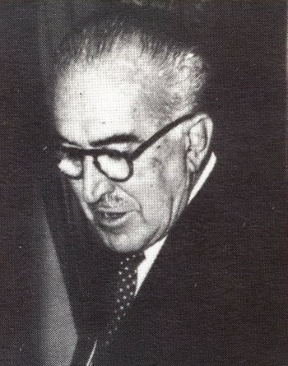
Figure 1 – Photo portrait of Manuel Mujica Millán (1960)
Source : Juan José Peréz Rancel, personal archive

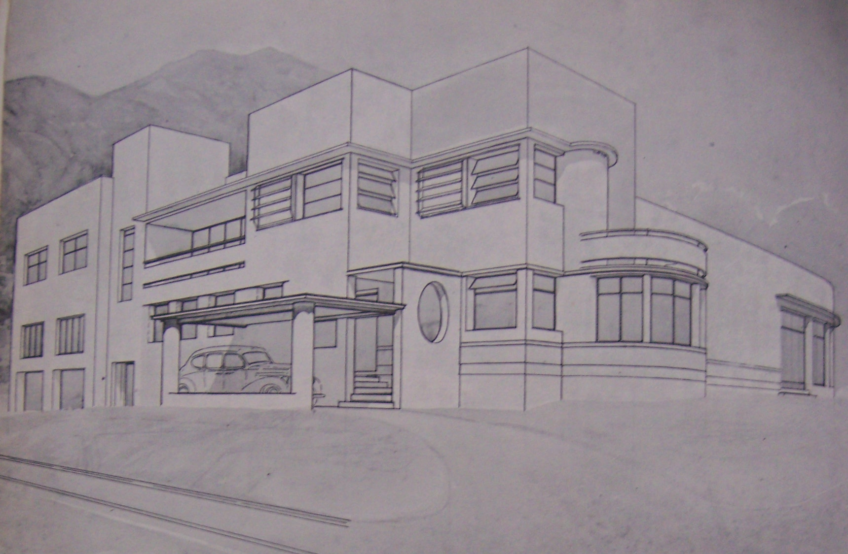Figure 2 – Quinta Casablanca
Source : J. P. Posani, Caracas a través de su arquitectura, Caracas, 1969.

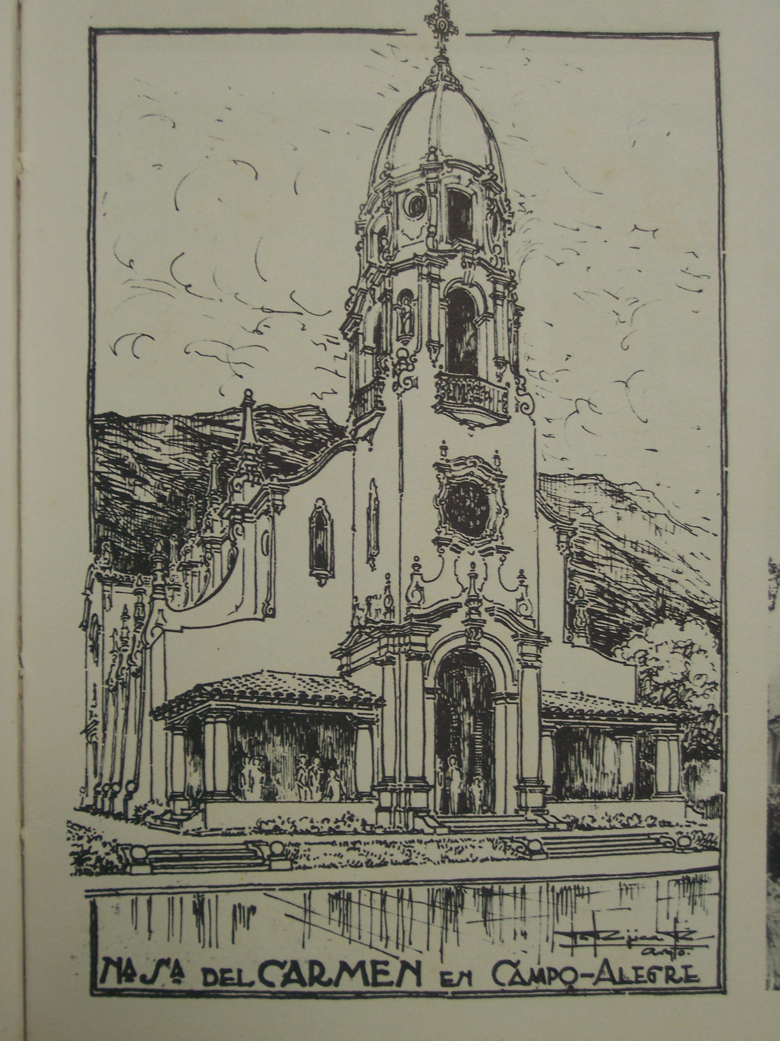
Figure 3 – Project for Nuestra Señora del Carmen Chapel
Source: J. P. Posani, Caracas a través de su arquitectura, Caracas, 1969.

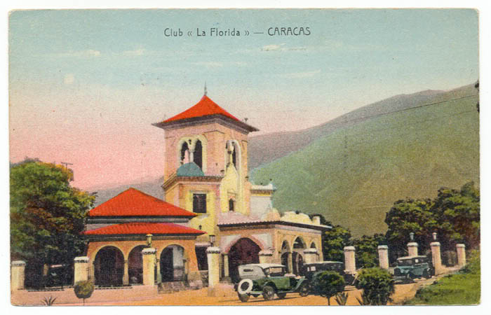Figure 4 – La Florida clubhouse (Caracas, 1935)
Source : Juan José Peréz Rancel, personal archive

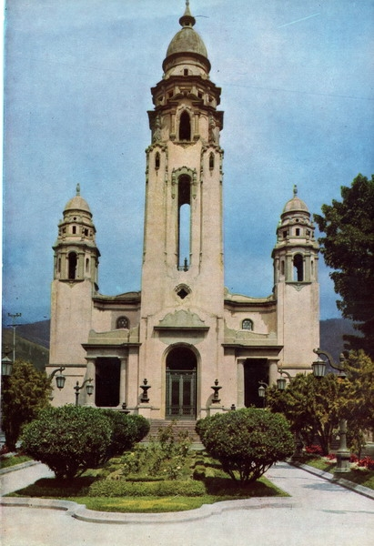
Figure 5 – National Pantheon (Caracas, 1930)
Source : Juan José Peréz Rancel, personal archive

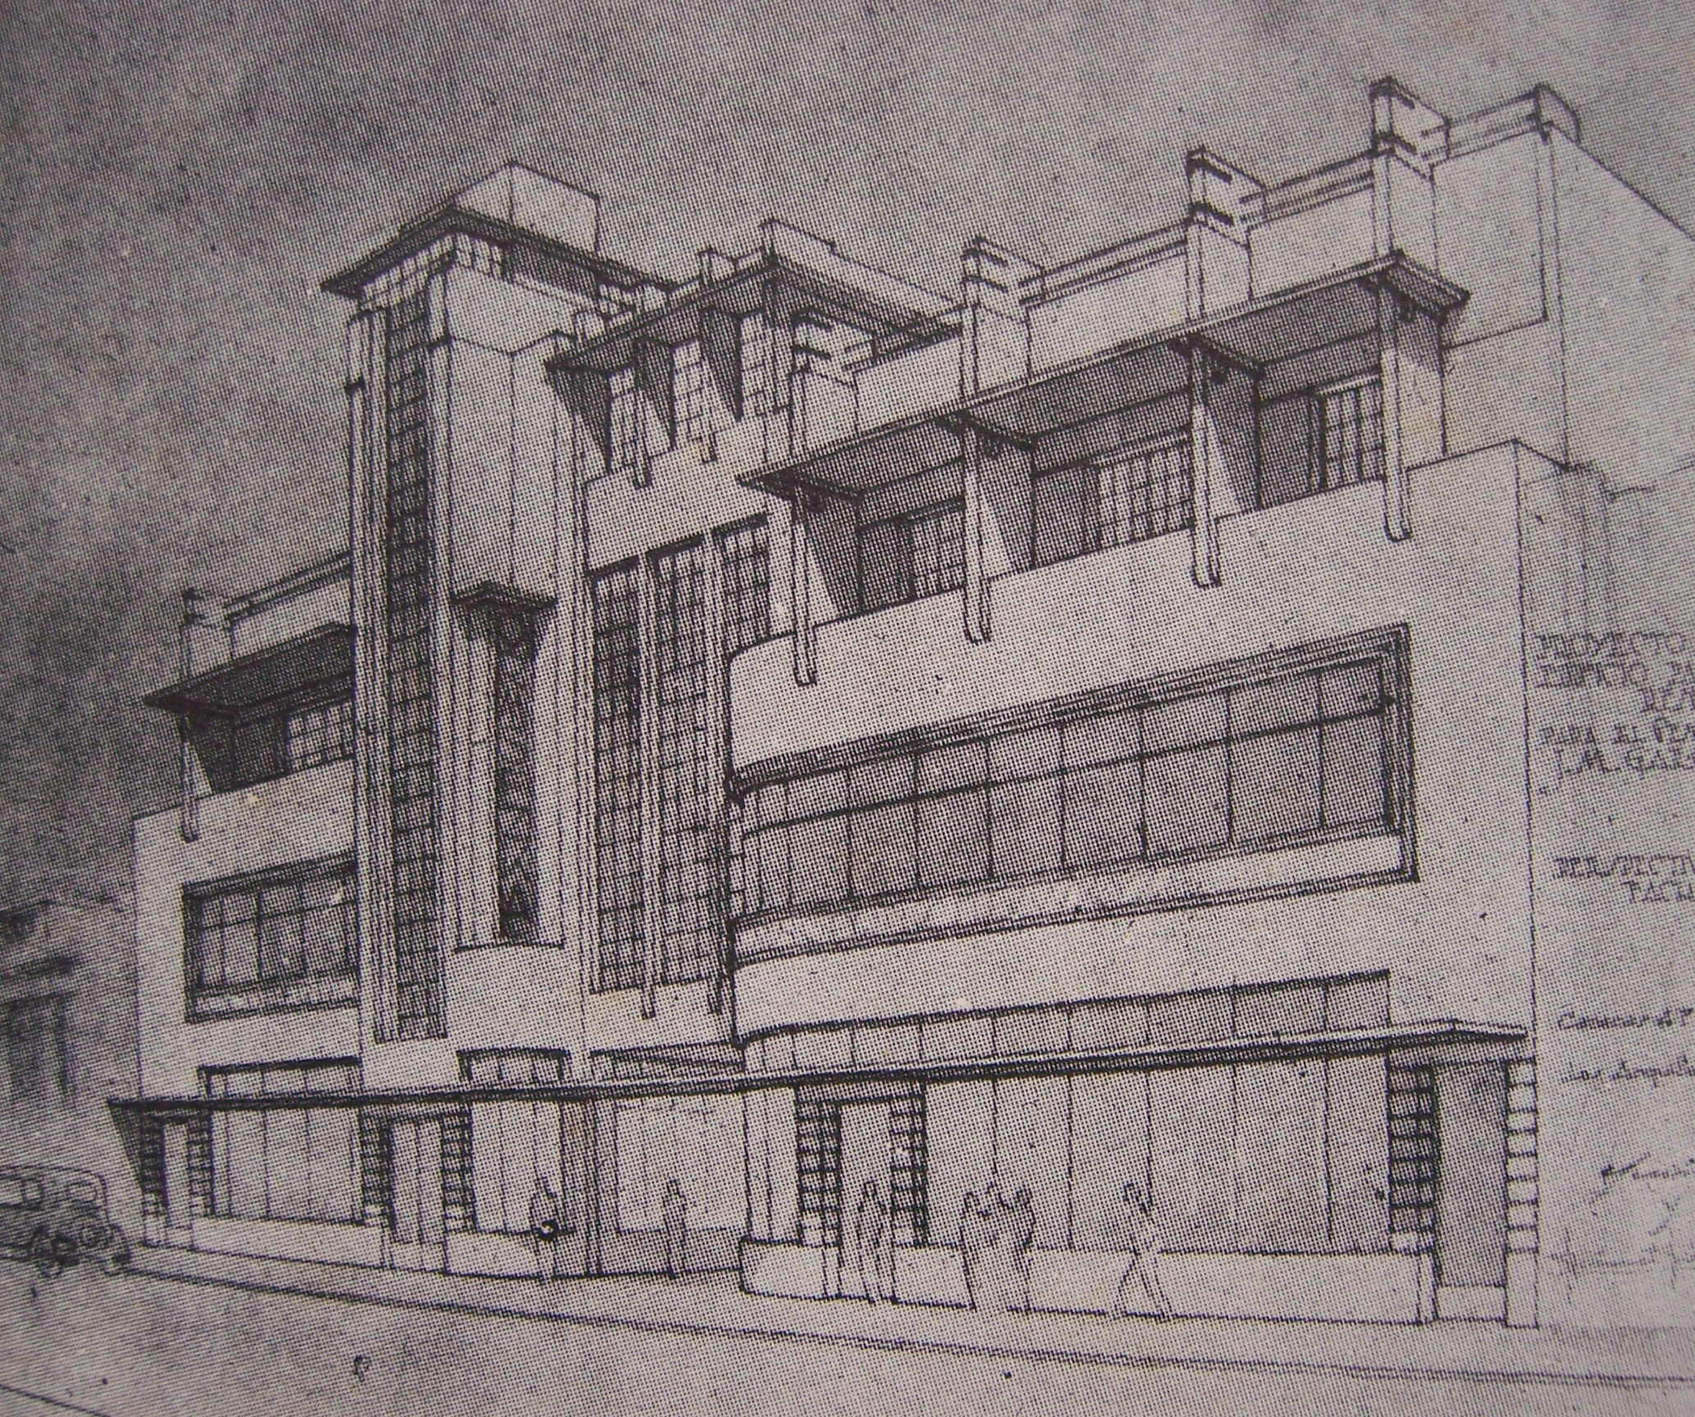
Figure 6 – Project for mixed-use building (with Guinand)
Source : J. P. Posani, Caracas a través de su arquitectura, Caracas, 1969.

Further readings:
Juan José Pérez Rancel, "La obra de Manuel Mujica Millán y los orígenes del Neohispanismo en la arquitectura de Venezuela" paper presented at La Arquitectura de Influencia Española en Venezuela, DOCOMOMO-Caracas, Caracas, 30 March 2011.

Lorenzo González Casas and Henry Vicente Garrido, "Arquitectura Neocolonial en Venezuela : Discursos Independentistas, Estilos Arquitectónicos y Patrimonio, XIV Encuentro de Latinoamericanistas Españoles, 2010. Available at: < http://hal.inria.fr/docs/00/53/05/49/PDF/AT7_Gonzalez-Garrido.pdf> (accessed 31/03/2014)

